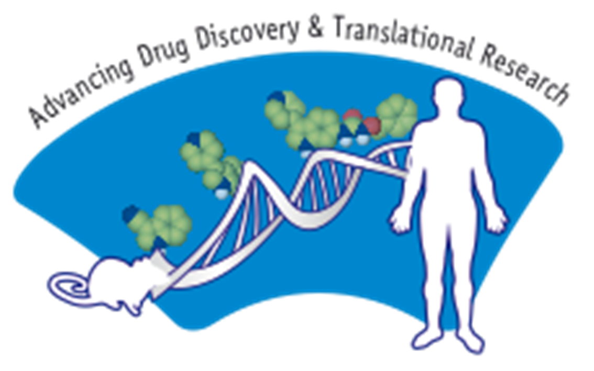 | Current Trends in Healthcare  “Advances in New Drug Discovery And Development”  February 6-8, 2020  Abstract Submission Form

 | Please return this Application Form by e-mail/airmail or fax to:
Deadline for  Abstract submission:  December 31, 2019 | Dr. Abhijit Chatterjee  Zydus Research Centre  Sarkhej-Bavla NH No 8a, Moraiya, Ahmedabad 382 213, Gujarat, India. |  | TEL: +91-2717-665555  FAX: +91-2717-665353  E-mail: abhijitchatterjee@zyduscadila.com  Website: http://www.rbfsymposium.net/
Presenting Author: Prof. Dr. Mr. Ms.
Last name: |  | First name: |  | Middle name:
Affiliation:
Mailing address:
City: |  | PIN/zip code: |  | Country:
Phone:+ |  | Fax:+ |  | E-mail:
Title of the Paper
Authors
Affiliation

Abstract (limit 250 words)

Important: Please do not exceed the box limits. This form will accept only text. For graphics/structures etc, please send a separate file/sheet.
Important: Please do not exceed the box limits. This form will accept only text. For graphics/structures etc, please send a separate filr/sheet

